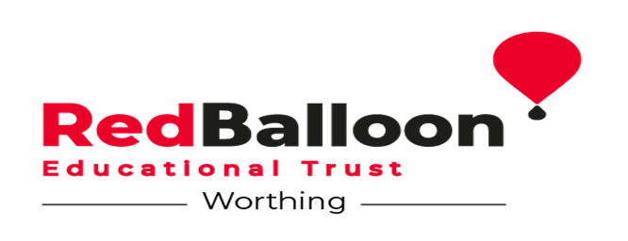

**Job Advert**

Job Title: Assistant Head/SENDCo

Location: Worthing, West Sussex

Hours: 40 Hours per week

Salary: £40,000

Start Date: September 1st 2025

This is a 1-year fixed term contract.

Working at Red Balloon Worthing takes a special kind of person. A person who loves to take the time to really get to know their students. They are kind, supportive and nurturing individuals who believe that progress comes in many forms. To excel in this role, you will enjoy working with young people and their families, supporting them to achieve both academically and socially. If this sounds like you then you may have just found the most rewarding job you ever had.

**Summary of role**

Our Assistant Head Teacher/SENDCo will be taking maternity leave and we need to find someone special to cover this important role at our Centre.

Ideally we are looking for a qualified SENDCO who can support our young people and their families, alongside our staff and Governors.

However, we can offer the right support for someone who has experience of working with young people with SEND, specifically ASC, SEMH and EBSA but does not have the NPQSEND or National SENDCO Award. We will have an Assistant SENDCO in post who will assist with completion of paperwork and support with interventions.

We are also interested in applicants who are interested in mentoring and coaching, promoting wellbeing and are willing to work with a dedicated team of mentors and Learning Support Assistants.

We are looking for someone who enjoys working face to face with young people and also their families to ensure their needs are fully met at the Centre.

Are you someone who enjoys being part of a close knit team, is a positive leader and wants to make a difference to the lives of young people every day? If so, then this could be the job for you.

### 

### **You can view a full job description and person specification below.**

[Join the team - Red Balloon Learner Centres](https://www.redballoonlearner.org/supporters-fundraisers/get-involved/join-the-team/)

### **How to Apply**

In line with safer recruitment practices, we are only able to accept applications via our application forms, which can be accessed by following the application link above. You can save your application at any point and come back to it at a later stage.

**Closing date:**

* The deadline for applications is **Friday 20th June 2025 at 12:00pm.**
* Interviews will be held week commencing the **23rd June 2025.**
* All applicants will be contacted to advise if they have been shortlisted for an interview

Red Balloon Educational Trust is committed to safeguarding and promoting the welfare of children and young people and requires the successful candidate to commit to this. The person appointed will be subjected to an enhanced DBS check.